**Crestron Certified Integrated Partner Module: Controller Receiver v2.0**

**Models:** Symetrix Integrator Series; 722, 760, 761, 780, 788. Jupiter Series; J4, J8, J12. SymNet; 8x8 DSP, Express Cobra DSP, Solus DSP, Edge DSP, Radius DSP.

**Device Type:** Audio Mixer, DSP.

**General Information**

The Certified Crestron Module SymNet Controller Receiver is used to receive serial string data from the Symetrix DSP and to transmit analog data to the Crestron system. It will accept a SymNet Controller Number and its value between (0) and (65,535) and can translate this into analog data to be used by Crestron system for displaying audio levels on a gauge drawn on the touch-panel using VTProe (Crestron's touch-panel graphics design software). SymNet Controller Receiver is a SIMPL+ module which will need to be added, saved and compiled in the User+ directory and brought into your SIMPL Program.

**Category:** Mixer, Audio DSP.

**Version:** 2.0

**Summary:** The SymNet Controller Receiver Crestron module is a SIMPL+ module that is used to read meter feedback for push enabled SymNet Controller Numbers.

**General Notes:**

Once a SymNet Controller Number is assigned to a meter and Push is enabled for the Controller Number the SymNet DSP will transmit string data every time the Controller Number's level changes. The SymNet system will also push this information after a refresh command is sent (PUR). Be sure that a gauge is drawn in the touch-panel file and have it associated with a Crestron Analog Join Number. The Analog Join will be represented on the Analog Signal Tab of the touch-panel in the SIMPL Program. Associate, by placing variables in the right places, this Analog Join will transmit meter data to the SymNet Controller Receiver module.

**Crestron Hardware Required:**

2 or 3 Series. RS-232, or UDP card required.

**Setup of Crestron Hardware:**

*RS-232.* Baud Rate; 38400 to 115200 - Configurable through SymNet Software Application. 8 Bit, Non-Parity, Stop Bit; 1, Flow Control; None.

*Crestron Cable Type.* CNSP-121

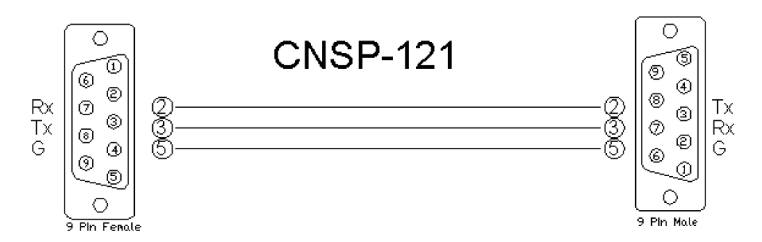

*UDP/IP.* Port: 48630.

**Application Notes:**

Although the majority of the gain stages (faders) available in SymNet Composer's DSP modules are on and 84dB scale; -72dBu to +12dBu. The majority of the meters; input/output, and meter modules are on a 72dB scale and are calibrated in dBFS (Full Scale).

It is highly recommended, especially in applications which are already heavy on processing power and communication back and forth, that the PUT (Push Threshold) command be used. After the SymNet Controller Number associated with the meter has been Push enabled; either through SymNet Composer, or by using a PUE command, you may want to limit how often the Symetrix piece transmits pushed meter data. You wouldn't necessarily want to have a string received every time the level changed by 1/65,535th of a degree. The PUT command can be used to set a Threshold below which a change in level will not be transmitted.

For Example; If the SymNet Controller Number #1 is assigned to a meter, the integrator could send PUT 1 781. 780.2 = 65,535/84. There are 780 counts on the SymNet 3rd Party Control Protocol Scale for an 84dBFS meter moving in 1dB increments. If the user only wanted to see meter movements after the level had changed by 3dB the you could send PUT 1 2341.

It is not necessary to have more than a single Controller Receiver module per meter type. If there are multiple meters required in the Crestron project and they are all operating on the same scale it would only be necessary to include (1) Controller Receiver module into the project. Extra lines for the placement of the touch-panel variable as well as the field for entering the additional Controller Numbers to be read can be added to the module in SIMPL Windows by using the ALT+ key. Pushed Data without Echo enabled will be transmitted from the SymNet DSP in the following format: #00001=65535. In this example Controller #1 is fully active at the top of its scale. The Crestron module, SymNet Controller Receiver will break up this string and for any Controller Number (value after the #) in the string, the module will transmit the various analog values transmitted (value after =).

**Module Graphic:**

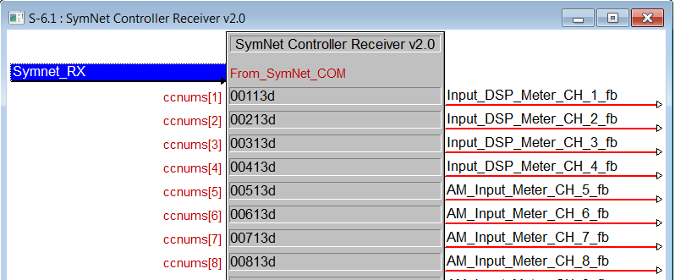

**Control:**

*Analog variable.* Signal Type: Analog. Place the variable in the fields to the right of the module. These variable statements will correspond to the location of the Crestron Analog Join Numbers that are present in the touch-panel module.

**Parameters:**

*ccnums.* Signal Type: Variable to be entered by the integrator. Enter in these availablefields the SymNet Controller Number that is associated with the meter. This will be the Controller Number whichis going to be pushing meter data and due to be analyzed by the module.

**Feedback:**

*From_SymNet_COM.* Signal Type: Serial. The Serial String returned information from the processor.

**Testing:**

*SymNet OS.* SymNet Designer v10.06, SymNet Composer v1.1, Jupiter Software v2.0.1.12, Integrator Series 761 Software v2.01. *SIMPL OS.* 4.01 *Crestron DB.* 35.00.004.00